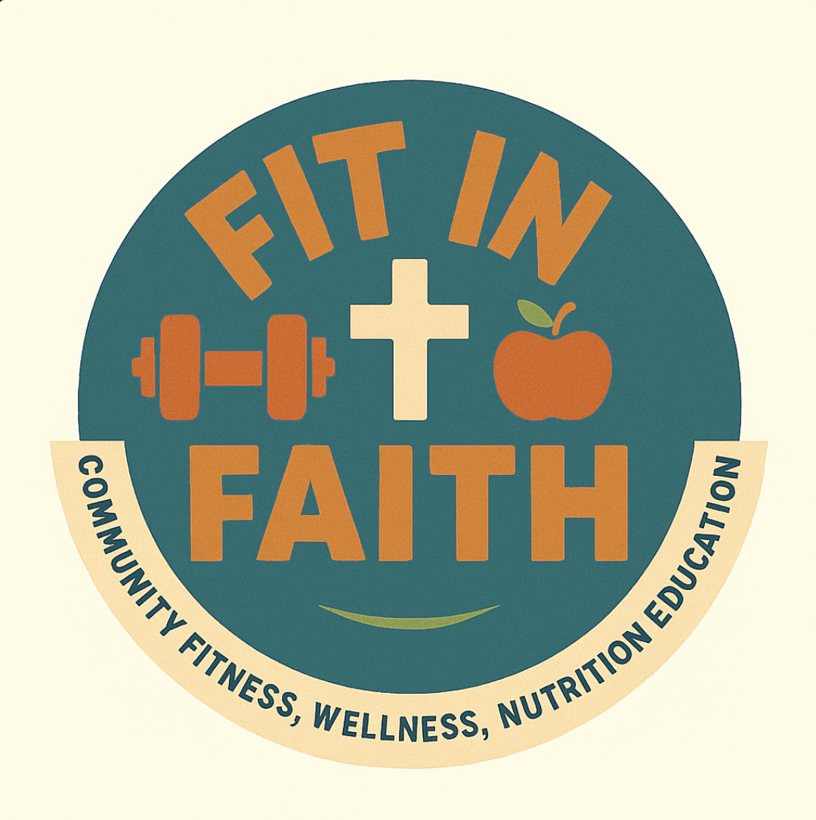
FIT IN FAITH
Announcement Script
For introducing the group to your congregation
When you are ready to invite your church to join, a short announcement from the front during service is one of the best ways to reach people. Below are a few versions you can read or adapt. Speak from the heart. You do not have to read it word for word.
Short Version (about 30 seconds)
"Good morning, church. We are starting a wellness group here called Fit in Faith. We come together to move our bodies, learn about our health, and grow in our faith, all at the same time. It is for every age and every ability, and no experience is needed. If you would like to take better care of the body God gave you, alongside your church family, come see us after service. We would love to have you."
Longer Version (about a minute)
"Good morning. Many of us want to take better care of our health, but it is hard to do alone. We are starting a group here at our church called Fit in Faith, and the idea is simple. We gather each week to move together, to learn about our health, and to open the Word and pray, because caring for our bodies is part of caring for what God has given us.
Every session has a seated option, so it truly is for everyone, whatever your age or ability. You do not need to be fit to start. You just need to come. We will laugh, we will move, we will pray, and we will do it together. If that sounds like something you need, and we think a lot of us do, please come talk to us after service. We cannot wait to get started with you."
Tips for the Person Speaking
- Smile and speak slowly. Your warmth matters more than your words.
- Say where and when the group will meet if you know it already.
- Have interest forms ready at the back so people can sign up right away.
- If two of you speak together, it shows this is a shared, welcoming effort.
Scripture You Can Weave In
Adding a verse gives your announcement a spiritual anchor and helps the congregation see wellness as part of their faith. Here are a few that fit well. Cite one near the start or the close.
Matthew 18:20
“For where two or three gather in my name, there am I with them.” A natural fit for inviting people to gather as a group.
1 Corinthians 6:19–20
“Your bodies are temples of the Holy Spirit... therefore honor God with your bodies.” Ties caring for our health directly to honoring God.
3 John 1:2
“I pray that you may enjoy good health and that all may go well with you, even as your soul is getting along well.” Connects physical health and spiritual wellbeing.
Ecclesiastes 4:9–10
“Two are better than one... if either of them falls down, one can help the other up.” Speaks to the strength of doing this together rather than alone.
Fit in Faith · fitinfaith.org

