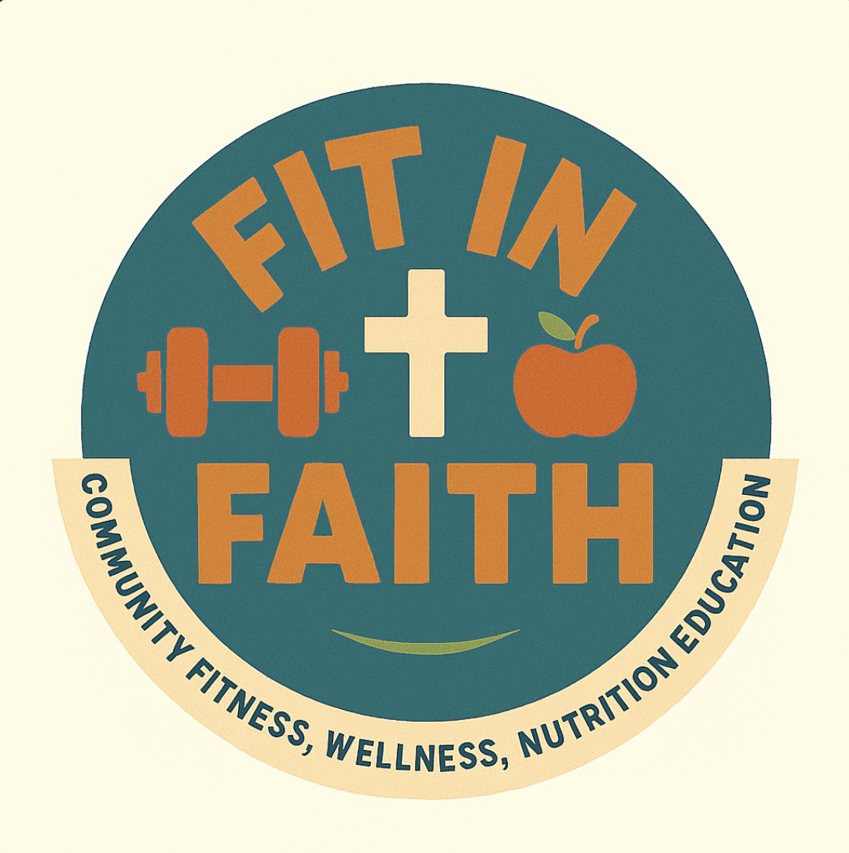
FIT IN FAITH
Scripture for Wellness
Verses on the body, health, and perseverance, with a word on each
These passages connect our faith to the care we give our bodies. Use them to open a session, to close in reflection, or to hand out for the week. Each one comes with a short thought to help you share it with your group.
1 Corinthians 6:19–20
“Do you not know that your bodies are temples of the Holy Spirit, who is in you, whom you have received from God? You are not your own; you were bought at a price. Therefore honor God with your bodies.”
Why it matters: Caring for our health is not vanity. It is one way we honor God with what he has entrusted to us.

Isaiah 40:31
“But those who hope in the Lord will renew their strength. They will soar on wings like eagles; they will run and not grow weary, they will walk and not be faint.”
Why it matters: On the days when progress feels slow, this reminds us that our strength is renewed when we lean on God, not only on ourselves.

Philippians 4:13
“I can do all this through him who gives me strength.”
Why it matters: A verse to carry into a hard workout or a hard week. Our effort and God's strength work together.

Proverbs 16:3
“Commit to the Lord whatever you do, and he will establish your plans.”
Why it matters: When we give our health goals to God, we make our plans with him rather than apart from him.

3 John 1:2
“Dear friend, I pray that you may enjoy good health and that all may go well with you, even as your soul is getting along well.”
Why it matters: God cares about our whole selves, body and soul together. Wellness of one supports the other.

Fit in Faith · fitinfaith.org

