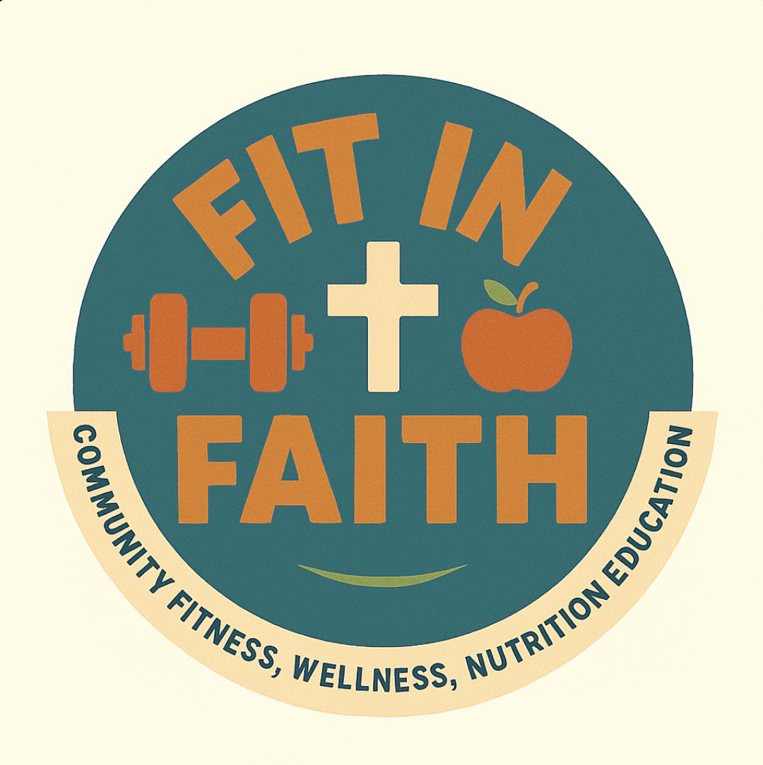
FIT IN FAITH
Words of Encouragement
Quotes and affirmations to lift your group
Encouragement carries people through the weeks when their motivation runs low. As the leader, you set the tone. Read one of these aloud to open a session, print them for the wall, or send one to the group between meetings. Speak them like you mean them, because your belief in your people is contagious.
Affirmations to Say Together
Lead these aloud and invite the group to repeat them back to you.
- My body is a gift, and I care for it with love.
- I am growing stronger, one small step at a time.
- I do not have to be perfect. I only have to keep going.
- God gave me this day, and I will use it well.
- I am worthy of rest, of health, and of joy.
- I am not alone. My community is walking with me.
- Every small choice I make for my health matters.
- I am capable of more than I know.
- I release what I cannot control and focus on what I can.
- My past does not decide my future.
- I honor God when I care for myself.
- I show up for myself and for the people beside me.
- Rest is not weakness. It is how I grow strong.
- I choose progress over perfection.
- I am proud of how far I have already come.
Words to Reflect On
"You are never too old to set another goal or to dream a new dream."
A reminder that it is never too late to begin.
"It does not matter how slowly you go as long as you do not stop."
Progress is progress, however small.
"Take care of your body. It is the only place you have to live."
A simple truth worth remembering on the hard days.
Using These With Your Group
- Open a session by reading one aloud and asking what it means to someone.
- Write one on a board or poster and leave it up through the week.
- Invite members to bring a favorite verse or saying of their own to share.
Fit in Faith · fitinfaith.org

